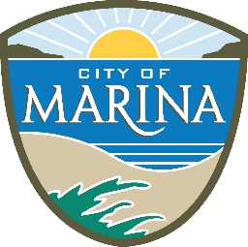
AGENDA

Tuesday, June 3, 2025 2:00 P.M - 3:30 P.M

TRAFFIC COMMITTEE
This meeting will be a hybrid meeting! If meeting in person at 209 Cypress Ave (Conference Room) at 2pm if attending via zoom, the zoom link is below
Join Zoom Meeting
https://us02web.zoom.us/j/84509559072?pwd=YzBkVW4rT3hpZVFhZnU2aS9hY05wQT09
Meeting ID: 845 0955 9072
Passcode: 809355
One tap mobile
+16694449171,84509559072# US
+16699009128,,84509559072# US (San Jose)

VISION STATEMENT

Marina will grow and mature from a small town bedroom community to a small city which is diversified, vibrant and through positive relationships with regional agencies, self-sufficient. The City will develop in a way that insulates it from the negative impacts of urban sprawl to become a desirable residential and business community in a natural setting. (Resolution No. 2006-112 - May 2, 2006)

- CALL TO ORDER

2. ROLL CALL: (Police Dept, Engineering/PW Dept, Community Development & Fire Dept) Chief Hopkins, Chief Doug McCoun, Carlos Vega, Guido Persicone, Edrie Delos Santos, Cmdr. Richard Cox, Steve Russo, PW Director Ismael Hernandez, Admin Michaelle Mowery

- ACTION ITEMS: Action listed for each Agenda item is that which is brought forth for Traffic Committee consideration and possible action. The Traffic Committee may, at its discretion, take action on any items. The public is invited to approach the podium to provide up to four (4) minutes of public comment.
  - 293 Carmel Ave. Replacement of Barricade
  - Stop Sign at Jetty/General Stillwell
  - Stop Sign 9th/Lighthouse
  - Cardoza/Abdy Signs
  - Deforest Speed
  - 234 Carmel & 3085 Sunset Red curb (First Baptist Chruch)
  - AIDS/Lifecycle Event Permit 9/20/25
Note: No additional major projects or programs should be undertaken without review of the impacts on existing priorities (Resolution No. 2006-79 – April 4, 2006).
4. DISCUSSION ITEMS:

NEXT TAC MEETING:
July 1, 2025

