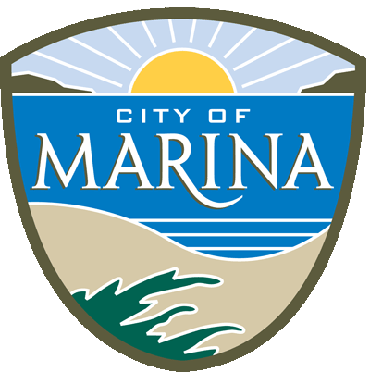

AGENDA-Canceled

Thursday, July 1, 2025 6:30 P.M.

PUBLIC WORKS COMMISSION NOTICE OF MEETING
Council Chambers
211 Hillcrest Avenue
Marina, California

VISION STATEMENT

Marina will grow and mature from a small town bedroom community to a small city which is diversified, vibrant and through positive relationships with regional agencies, self-sufficient. The City will develop in a way that insulates it from the negative impacts of urban sprawl to become a desirable residential and business community in a natural setting. (Resolution No. 2006-112 - May 2, 2006)

MISSION STATEMENT

The City Council will provide the leadership in protecting Marina’s natural setting while developing the City in a way that provides a balance of housing, jobs and business opportunities that will result in a community characterized by a desirable quality of life, including recreation and cultural opportunities, a safe environment and an economic viability that supports a high level of municipal services and infrastructure. (Resolution No. 2006-112 - May 2, 2006)

- CALL TO ORDER

2. ROLL CALL & ESTABLISHMENT OF QUORUM:
James Felton, Stephen Rouland, Steven Hunt, Jaime Schrabeck, Joosik Choi
3. MOMENT OF SILENCE & PLEDGE OF ALLEGIANCE (Please stand)

4. SPECIAL PRESENTATIONS:

5. SPECIAL ANNOUNCEMENTS AND COMMUNICATIONS AND PUBIC COMMENT FROM THE FLOOR: Announcements of special events or meeting of interest as information to Public Works Commission and Public. At this time any person may comment on any item, which is not on the agenda. Please state your name and address for the record. Action will not be taken on an item that is not on the agenda. If it requires action, it will be referred to staff and/or placed on the next agenda. Public Works Commission members or City staff may briefly respond to statements made or questions posed as permitted by Government Code Section 54954.2. In order that all interested parties have an opportunity to speak, please limit comments to a maximum of Four (4) minutes. Any member of the public may comment on any matter listed on this agenda at the time the matter is being considered by the Public Works Commission.

6. CONSENT AGENDA: Background information has been provided to the Public Works Commission on all matters listed under the Consent Agenda, and these items are considered to be routine. All items under the Consent Agenda are normally approved by one motion. If discussion is requested by anyone on any item, that item will be removed from the Consent Agenda and placed at the end of Action Items if separate action is requested.

7. ACTION ITEMS: Action listed for each Agenda item is that which is brought forth for Public Works Commission consideration and possible action. The Public Works Commission may, at its discretion, take action on any items. The public is invited to approach the podium to provide up to four (4) minutes of public comment.

Note: No additional major projects or programs should be undertaken without review of the impacts on existing priorities (Resolution No. 2006-79 – April 4, 2006).

8. COMMISSIONERS & STAFF INFORMATIONAL REPORTS:

9. CORRESPONDENCE

- None

10. ADJOURNMENT

CERTIFICATION

I, Michaelle M. Mowery, Administrative Assistant for the City of Marina, do hereby certify all meetings take place in the Council Chambers unless otherwise noticed. Public notices and agendas are posted at the following locations: Monterey County Library Marina Branch, Kiosk at the corner of Del Monte Blvd. and Reservation Rd., and Marina City Council Chambers Bulletin Board on or before 6:30 P.M., Friday, June 27, 2025.

________________________________________________
MICHAELLE M. MOWERY, ADMINISTRATIVE ASSISTANT II

